**Hackathon Project Phases Template** for the **TransLingua: AI-Powered Multi-Language Translator** project.

# **Hackathon Project Phases Template**

## **Project Title:**

**TransLingua: AI-Powered Multi-Language Translator**

## **Team Name:**

Innovision

## **Team Members:**

* Miryala Pavani
* Midivelli Tejasri
* Lasunoju Haripriya

## **Phase-1: Brainstorming & Ideation**

### **Objective:**

Develop an AI-Powered Multi-Language Translator is to bridge communication gaps between people who speak different languages by providing accurate, fast, and context-aware translations

**Key Points:**

1. **Problem Statement:**

* TransLingua is a cutting-edge web application designed to harness the power of advanced AI to provide seamless language translation services. Built using Streamlit and Google's Generative AI, TransLingua offers an intuitive and user-friendly interface for translating text between multiple languages.
* By simply inputting text and selecting the desired source and target languages, users can instantly receive accurate translations powered by the latest AI models. This tool is ideal for anyone needing reliable and fast translations, whether for personal, educational, or professional purposes.

1. **Proposed Solution:**
   * It would involve leveraging state-of-the-art AI and NLP technologies to create a robust, scalable, and user-friendly translation system.
   * TransLingua can add subtitles to your videos. They can translate the subtitles into other languages.
   * TransLingua can provide voice over services for your videos and other media. They have a team of voice actors who are fluent in a variety of languages.
2. **Target Users:**
   * **Business:** International communication, marketing, website translation.
   * **Government**: Citizen communication, document translation, hearings.
   * **Education**: Student/parent communication, course material translation, events.
   * **Healthcare**: Patient communication, medical records translation, appointments.
3. **Expected Outcome:**
   * **Accurate Translation**: Ensuring the meaning is conveyed correctly.

## **Phase-2: Requirement Analysis**

### **Objective:**

Define the technical and functional requirements for the AI-Powered Multi Language Translator.

### **Key Points:**

1. **Technical Requirements:**
   * Programming Language: **Python, Java Script**
   * Backend: **Languages like Python, Java, Node.js**
   * Frontend: **Java Script Framework like React, Angular or Vue.js**
   * Database: **MySQL, PostgreSQL or NoSQL (Ex: MongoDB)**
2. **Functional Requirements:**
   * **User Input Handling:** Accept text, speech, and document inputs.
   * **Language Detection:** Identify the source language automatically.
   * **Automatic Speech Recognition (ASR):** Convert speech to text.
   * **User Interface & Experience:** Provide a user-friendly interface (web/app/desktop).
   * **Output Customization:** Allow users to adjust translation formality/tone.
3. **Constraints & Challenges:**
   * Latency: Ensuring low response times for speech-to-text and text-to-speech translation.
   * Grammar & Sentence Structure: Some languages have vastly different syntax, making direct translation inaccurate.
   * Scalability: Handling large volumes of concurrent translation requests efficiently.

## **Phase-3: Project Design**

### **Objective:**

Develop the architecture and user flow of the application.

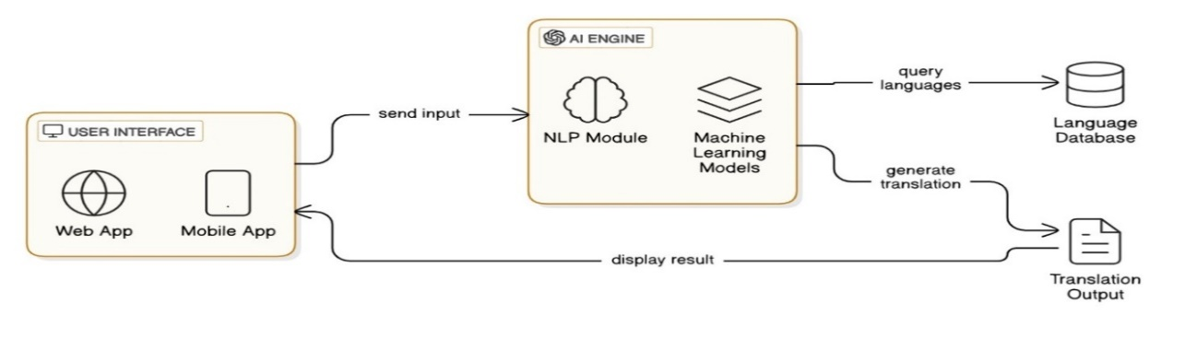

### **Key Points:**

1. **System Architecture:**
   * Text Input: Allows users to type or paste text for translation.
   * Uses cloud platforms like AWS, Google Cloud, for scalability and reliability.
   * A browser-based interface for desktop users.
   * Improves performance by caching frequently used translations (e.g. Redis).
2. **User Flow:**
   * Step 1: User Accesses the Platform.
   * Step 2: Input Submission.
   * Step 3: Processing.
   * Step 4: Output Generation
   * Step 5: User Actions
   * Step 6: Logging & Feedback
3. **UI/UX Considerations:**
   * **Automatic Language Detection**: Implement features that automatically detect the user's input language to streamline the translation process.
   * **Simplified Text**: Use straightforward language in the interface to accommodate non-native speakers and facilitate easier translation.

## 

## **Phase-4: Project Planning (Agile Methodologies)**

### **Objective:**

Break down development tasks for efficient completion.

|  |  |  |  |  |  |  |  |
| --- | --- | --- | --- | --- | --- | --- | --- |
| **Sprint** | **Task** | **Priority** | **Duration** | **Deadline** | **Assigned To** | **Dependencies** | **Expected Outcome** |
| Sprint 1 | Environment Setup | 🔴 High | 8 hours (Day 1) | End of Day 1 | Midivelli Tejasri | Server Infrastructure, Development Tools | Development Environment Configured with necessary libraries and Frameworks. |
| Sprint 1 | Translation API Integration | 🔴 High | 12 hours (Day 1) | End of Day 1 | Midivelli Tejasri | API Keys, Documentation | Successful Integration with chosen Translation  API. |
| Sprint 2 | User Authentication | 🔴 High | 10 hours (Day 2) | End of Day 2 | Lasunoju Haripriya | Database Setup | Secure user registration and login implemented. |
| Sprint 2 | Language Selection | 🟡 Medium | 6 hours (Day 2) | End of Day 1 | Lasunoju Haripriya | Translation API Integration | Dropdown menus for source and target language Selection. |
| Sprint 3 | Bug Fixing | 🔴 High | 8 hours (Day 2) | End of Day 2 | Miryala Pavani | Initial User Testing | All critical bugs resolved. |
| Sprint 3 | Final Presentation & Deployment | 🟢 Low | 4 hours (Day 2) | End of Day 2 | Entire Team | Deployment Preparation | Translingua platform live and accessible. |

### 

### **Sprint Planning with Priorities**

**Sprint 1 – Environment Setup & Translation API Integration (Day 1)**

**(🔴 High Priority)** Development Environment Configured with necessary libraries and Frameworks.  
 **(🔴 High Priority)** Successful Integration with chosen Translation API.

### **Sprint 2 – User Authentication** **&** **Language Selection** **(Day 2)**

**(🔴 High Priority)** Secure user registration and login implemented.  
 **(🟡 Medium Priority)** Dropdown menus for source and target language Selection.

### **Sprint 3 – Bug Fixing & Final Presentation & Deployment (Day 2)**

**(🔴 High Priority)** All critical bugs resolved.  
 **(🟢 Low Priority)** Translingua platform live and accessible.

## **Phase-5: Project Development**

### **Objective:**

Implement core features of the AI-Powered Multi Language Translator.

### **Key Points:**

1. **Technology Stack Used:**
   * **Frontend:** Web, Mobile, UI Frameworks
   * **Backend:** Frameworks (FastAPI, Flask)
   * **Programming Language:** Python, Java Script
2. **Development Process:**
   * Planning & Requirements Gathering
   * Technology Selection
   * Data Collection & Model Training
   * Backend Development
   * Frontend Development
   * Testing & Quality Assurance
   * Deployment & Scaling
   * Monitoring & Continuous Improvement
3. **Challenges & Fixes:**
   * **Challenge:** Ambiguity–Words may have multiple meanings across languages.  
      **Fix:** Use context-aware translation and AI models trained on large datasets.
   * **Challenge:** Hard to translate cultural nuances accurately.  
      **Fix:** Use native translators and cultural adaptation strategies.

## **Phase-6: Functional & Performance Testing**

### **Objective:**

Ensure that the TransLingua: AI- Powered Multi Language Translator works as expected.

|  |  |  |  |  |  |
| --- | --- | --- | --- | --- | --- |
| **Test Case ID** | **Category** | **Test Scenario** | **Expected Outcome** | **Status** | **Tester** |
| TC-001 | Functional Testing | Translate “Hello, how are you?” to Spanish | “Hola, comoestas?” | ✅ Passed | Midivelli Tejasri |
| TC-002 | Functional Testing | Detect and auto-translate mixed-language input | Correct languages should be detected and translate accurately | ✅ Passed | Lasunoju Haripriya |
| TC-003 | Performance Testing | Response time under 500ms for translation | API should return results quickly. | ⚠ Needs Optimization | Midivelli Tejasri |
| TC-004 | Bug Fixes & Improvements | Fixed incorrect sentence structure in German | Translations should be grammatically correct | ✅ Fixed | Miryala Pavani |
| TC-005 | Final Validation | UI should be responsive on mobile & desktop | App should work smoothly across devices | ❌ Failed - UI broken on mobile | Lasunoju Haripriya |
| TC-006 | Deployment Testing | Host the app using Streamlit Sharing | App should be accessible online. | 🚀 Deployed | Miryala Pavani |

## **Final Submission**

1. **Project Report Based on the templates**
2. **Demo Video (1-3 Minutes)**
3. **GitHub/Code Repository Link**
4. **Presentation**